AI Workflow Audit

Muhammad Hamza
Email: hamzatanvir501@gmail.com

Primary AI Development Environment
Google Antigravity is my primary AI-assisted development environment. I use AI tools to improve my software development workflow, including planning, debugging, documentation, research, and productivity improvement.
Additional AI tools:
- ChatGPT
- Claude
- Kilo Code
- OpenCode
- Blackbox
Completed Learning:
- Anthropic Academy - AI Fluency: Framework & Foundations

Weekly AI Workflow Audit
# | Recurring Task | Classification | Rationale
1 | Designing frontend development projects architecture and selecting technologies | Collaborate with AI | AI can suggest architectures and compare approaches, but final architecture decisions require my technical judgment and understanding of project goals.
2 | Debugging Python, JS, React, and backend issues | Collaborate with AI | AI helps identify possible causes and solutions, but I verify fixes and understand the root problem before applying changes.
3 | Writing project documentation, README files, and technical reports | Delegate to AI with review | AI can improve structure, clarity, and formatting, but I review technical correctness before publishing.
4 | Generating boilerplate code and project templates | Fully automate | Repetitive code structures can be generated quickly by AI with minimal manual effort.
5 | Creating test cases and validation scenarios | Delegate to AI with review | AI can generate test ideas and edge cases, but I verify whether they match real requirements.
6 | Researching new AI frameworks, libraries, and technologies | Collaborate with AI | AI accelerates research and explanations, while I evaluate reliability, limitations, and practical usage.
7 | Improving code quality through reviews and refactoring suggestions | Delegate to AI with review | AI can identify improvements, but I decide which changes are suitable for the project.
8 | Preparing internship documentation and project submissions | Delegate to AI with review | AI helps organize information, but the final submission must represent my actual work and experience.
9 | Writing Git commit messages and maintaining documentation standards | Delegate to AI with review | AI can suggest professional formatting, while I ensure commits accurately describe real changes.
10 | Data cleaning and exploratory data analysis | Collaborate with AI | AI can assist with patterns and analysis, but I validate the data quality and interpretation.

Tasks That Should Remain Human Controlled (Just Me)
# | Task | Classification | Rationale
11 | Making final technical decisions for projects | Just Me | Engineering ownership and responsibility cannot be delegated because the final decision impacts project quality, maintainability, and future development.
12 | Understanding real user requirements and business needs | Just Me | Human communication, context understanding, and requirement clarification require direct interaction and judgment.
13 | Taking responsibility for final submitted work | Just Me | I must personally verify that all submitted work represents my skills, understanding, and ethical standards.
14 | Choosing my career direction and professional goals | Just Me | Career decisions depend on personal interests, values, long-term goals, and life circumstances. AI can provide information but cannot make the decision for me.
15 | Evaluating whether AI-generated information is trustworthy | Just Me | Critical thinking is required to identify incorrect assumptions, hallucinations, or unsuitable recommendations before using AI output.

AI Collaboration Principles
My approach to AI-assisted development:
- AI is used as a productivity partner, not a replacement for engineering judgment.
- Every AI-generated output is reviewed before being accepted.
- Sensitive information, credentials, and private data are never shared with AI tools.
- Human responsibility remains with the developer for all final decisions.
- AI should improve my workflow while helping me build stronger technical understanding.

Selected Tasks for FL-02 to FL-04
Task 1: AI-Assisted Debugging
Goal:
Use AI to reduce debugging time for software issues in backend and AI projects.
Success Definition:
A successful workflow means:
- AI helps identify possible root causes.
- The final solution fixes the actual issue.
- I understand why the issue happened.
- No unnecessary changes are introduced.
- The application remains stable after the fix.

Task 2: AI-Assisted Documentation Improvement
Goal:
Use AI to improve project documentation quality.
Success Definition:
A successful workflow means:
- Documentation is clear for new developers.
- Setup instructions can be followed successfully.
- Technical explanations remain accurate.
- AI improves readability without changing the original meaning.

Task 3: AI-Assisted Project Planning
Goal:
Use AI to convert project ideas into structured implementation plans.
Success Definition:
A successful workflow means:
- Requirements are converted into actionable tasks.
- Architecture decisions are documented.
- Development risks are identified.
- The implementation roadmap is realistic.
- The final plan helps reduce development uncertainty.

Tools and Evidence
Primary AI Environment:
- Google Antigravity
Supporting AI Tools:
- ChatGPT
- Claude
- Kilo Code
- OpenCode
- Blackbox
Learning Completed:
- Anthropic Academy - AI Fluency: Framework & Foundations

Claude Project
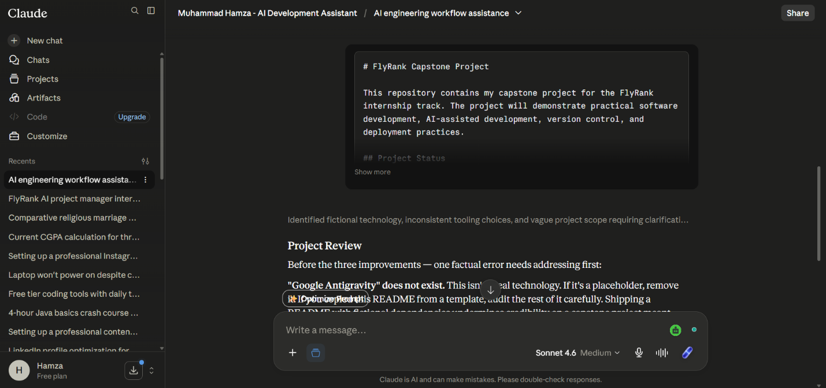

Antigravity – AI Assistant in tasks
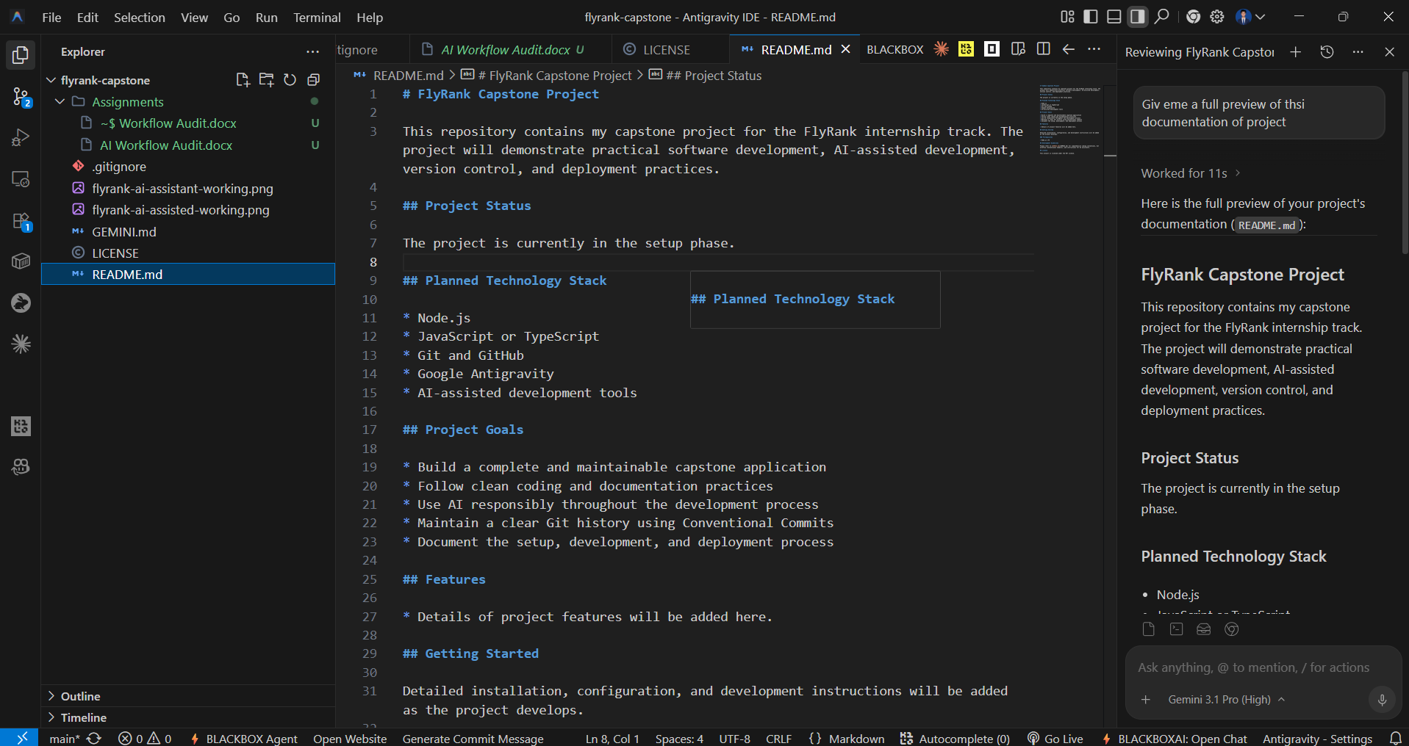

AI Fluency: Foundations and Frameworks certificate
